DAD220

Module 7 Project 2

Dr. Linda Wilson

Andrea Plunkett- Jackson

08/10/2023

1.Begin by writing SQL commands to**capture usable data** (which you’ve preloaded into Codio) for your analysis.

chmod +x change_perm.sh

./change_perm.sh

mysql

USE Quantigrationupdates2;

SHOW TABLES;

DESCRIBE Collaborators;

DESCRIBE Orders;

DESCRIBE RMA;

SELECT COUNT(*) FROM Collaborators;

SELECT COUNT(*) FROM Orders;

SELECT COUNT(*) FROM RMA;

SELECT * FROM RMA LIMIT 33;

SELECT * FROM Orders LIMIT 33;

SELECT * FROM Collaborators LIMIT 33;

2.Specifically, the product manager wants you to analyze the following:

* **Analyze** the **number of returns** **by state** and describe your findings in your report.

SELECT Collaborators.State AS State, Count(*) AS Return_Number FROM Orders

INNER JOIN RMA ON Orders.OrderID = RMA.OrderID

INNER JOIN Collaborators ON Collaborators.CollaboratorID = Orders.CollaboratorID

GROUP BY State

ORDER BY Return_Number DESC LIMIT 25;

SELECT Collaborators.State AS State, Count(*) AS Return_Number FROM Orders

INNER JOIN RMA ON Orders.OrderID = RMA.OrderID

INNER JOIN Collaborators ON Collaborators.CollaboratorID = Orders.CollaboratorID

GROUP BY State

ORDER BY Return_Number DESC LIMIT 50;

* **Analyze**the **percentage of returns by product type** and describe your findings in your report.

SELECT SKU AS Product_SKU, Description AS Product_Description, (COUNT(*) / (SELECT COUNT(*) FROM Orders

INNER JOIN RMA ON Orders.OrderID = RMA.OrderID) * 100 ) AS Percentages_Of_Returns FROM Orders

INNER JOIN RMA ON Orders.OrderID = RMA.OrderID WHERE UPPER(Status) = "COMPLETE"

GROUP BY Product_SKU

ORDER BY Percentages_Of_Returns

DESC LIMIT 15;

SELECT Collaborators.State AS STATE, COUNT(*) AS RETURNS_PER_STATE,

COUNT(*)/(SELECT COUNT(*) FROM RMA

WHERE Status = 'Complete') *100 AS Percentage

FROM Collaborators

INNER JOIN Orders ON Collaborators.CollaboratorID = Orders.CollaboratorID

INNER JOIN RMA ON Orders.OrderID = RMA.OrderID

WHERE UPPER(RMA.Status) = 'Complete'

GROUP BY STATE

ORDER BY RETURNS_PER_STATE DESC LIMIT 25;

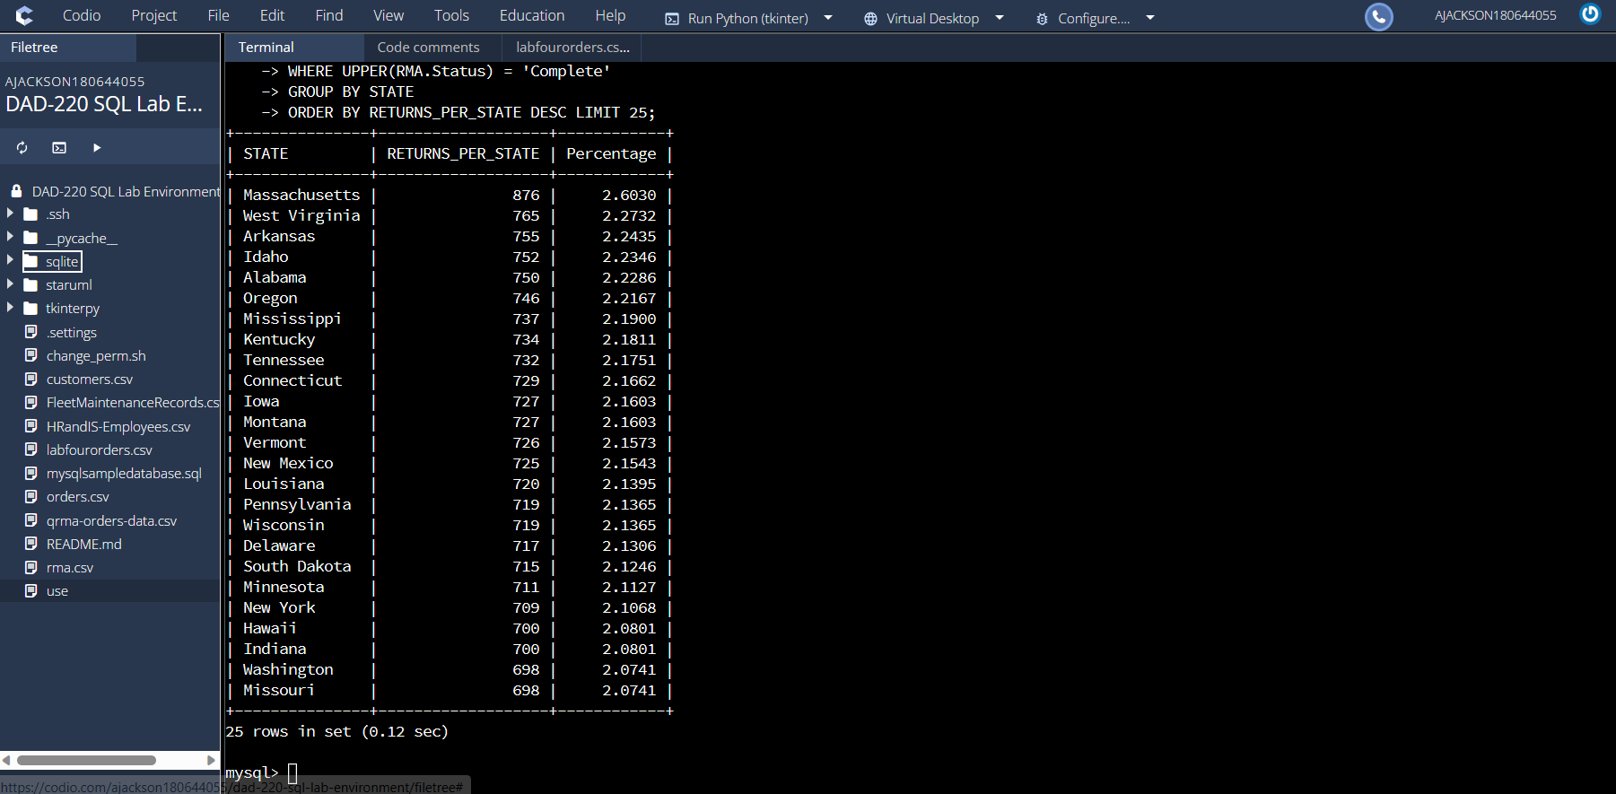

SELECT Collaborators.State AS STATE, COUNT(*) AS PRODUCT_SALES_NUMBER

FROM Collaborators INNER JOIN Orders ON Collaborators.CollaboratorID = Orders.CollaboratorID

GROUP BY STATE

ORDER BY PRODUCT_SALES_NUMBER DESC

LIMIT 20;

SELECT Collaborators.State AS STATE, COUNT(*) AS RETURNS_PER_STATE,

COUNT(*)/(SELECT COUNT(*) FROM RMA

WHERE Status = 'Complete') *100 AS Percentage

FROM Collaborators

INNER JOIN Orders ON Collaborators.CollaboratorID = Orders.CollaboratorID

INNER JOIN RMA ON Orders.OrderID = RMA.OrderID

WHERE UPPER(RMA.Status) = 'Complete'

GROUP BY STATE

ORDER BY RETURNS_PER_STATE DESC LIMIT 50;

SELECT RMA.Reason AS RETURN_REASON,

COUNT(*) AS NUMBER_OF_RETURNS,

COUNT(*)/(SELECT COUNT(*) FROM RMA

WHERE UPPER(Status) = 'Complete') *100 AS PERCENTAGE FROM RMA

WHERE UPPER(Status) = 'Complete'

GROUP BY RMA.Reason ORDER BY NUMBER_OF_RETURNS DESC;

SELECT Orders.Description AS PRODUCT_DESCRIPTION,

COUNT(*) AS NUMBER_OF_RETURNS,

COUNT(*)/(SELECT COUNT(*) FROM RMA

WHERE UPPER(Status) = 'Complete') *100 AS PERCENTAGE_OF_RETURNS FROM RMA

INNER JOIN Orders ON RMA.OrderID = Orders.OrderID

WHERE UPPER(Status) = 'Complete'

GROUP BY Orders.Description

ORDER BY NUMBER_OF_RETURNS DESC;

SELECT (SELECT COUNT(*) FROM Orders) AS NUMBER_OF_ORDERS,

COUNT(*) AS NUMBER_OF_RETURNS,

COUNT(*)/(SELECT COUNT(*) FROM Orders) *100 AS Percentage_Of_Orders_returned

FROM Collaborators

INNER JOIN Orders ON Collaborators.CollaboratorID = Orders.CollaboratorID

INNER JOIN RMA ON Orders.OrderID = RMA.OrderID

WHERE UPPER(RMA.Status) = 'Complete';

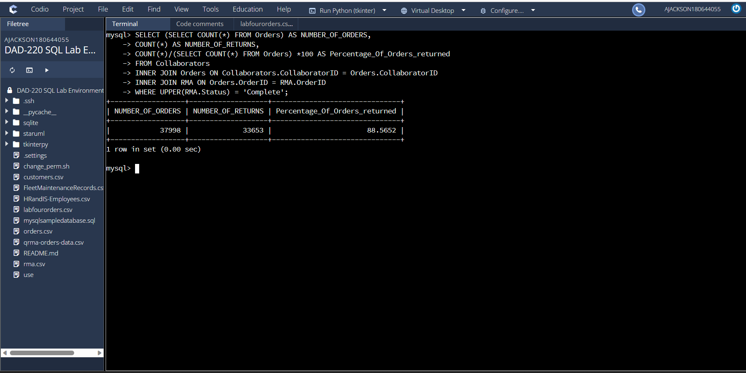

SELECT "Basic Switch" AS PRODUCT_TYPE,

(SELECT COUNT(*) FROM Orders

WHERE UPPER(Orders.Description) LIKE '%BASIC%') AS NUMBER_OF_ORDERS,

COUNT(*) AS NUMBER_OF_RETURNS,

COUNT(*)/(SELECT COUNT(*) FROM Orders

WHERE UPPER(Orders.Description) LIKE '%BASIC%')*100 AS PERCENT_OF_ORDER_TYPE_RETURNED FROM RMA

INNER JOIN Orders ON RMA.OrderID = Orders.OrderID

WHERE UPPER(RMA.Status) = 'Complete' AND

UPPER(Orders.Description) LIKE '%BASIC%'

UNION

SELECT "Advanced Switch" AS PRODUCT_TYPE,

(SELECT COUNT(*) FROM Orders

WHERE UPPER(Orders.Description) LIKE '%ADVANCED%') AS NUMBER_OF_ORDERS,

COUNT(*) AS NUMBER_OF_RETURNS,

COUNT(*)/(SELECT COUNT(*) FROM Orders

WHERE UPPER(Orders.Description) LIKE '%ADVANCED%')*100 AS PERCENT_OF_ORDER_TYPE_RETURNED FROM RMA

WHERE UPPER(Status) = 'Complete') *100 AS PERCENTAGE_OF_RETURNS FROM RMA

INNER JOIN Orders ON RMA.OrderID = Orders.OrderID

WHERE UPPER(RMA.Status) = 'Complete' AND

UPPER(Orders.Description) LIKE '%ADVANCED%'

UNION

SELECT "Enterprise Switch' AS PRODUCT_TYPE,

(SELECT COUNT(*) FROM Orders

WHERE UPPER(Orders.Description) LIKE '%ENTERPRISE%') AS NUMBER_OF_ORDERS,

COUNT(*) AS NUMBER_OF RETURNS,

COUNT(*)/(SELECT COUNT(*) FROM Orders

WHERE UPPER(Orders.Description) LIKE '%ENTERPRISE%')*100 AS PERCENT_OF_ORDER_TYPE_RETURNED FROM RMA

INNER JOIN Orders ON RMA.OrderID = Orders.OrderID

WHERE UPPER(RMA.Status) = 'Complete' AND

UPPER(Orders.Description) LIKE '%ENTERPRISE%'

ORDER BY PERCENT_OF_ORDER_TYPE_RETURNED DESC;

SELECT "Basic Switch" AS PRODUCT_TYPE, COUNT(*) AS NUMBER_OF_RETURNS, COUNT(*)/(SELECT COUNT(*) FROM RMA

WHERE UPPER(Status) = 'Complete')*100 AS PERCENTAGE_OF_RETURNS FROM RMA

INNER JOIN Orders ON RMA.OrderID = Orders.OrderID

WHERE UPPER(RMA.Status) = 'Complete' AND

UPPER(Orders.Description) LIKE '%BASIC%'

UNION

SELECT "Advanced Switch" AS PRODUCT_TYPE,COUNT(*) AS NUMBER_OF_RETURNS, COUNT(*)/(SELECT COUNT(*) FROM RMA

WHERE UPPER(Status) = 'Complete')*100 AS PERCENTAGE_OF_RETURNS

FROM RMA

INNER JOIN Orders ON RMA.OrderID = Orders.OrderID

WHERE UPPER(RMA.Status) = 'Complete' AND

UPPER(Orders.Description) LIKE '%ADVANCED%'

UNION

SELECT "Enterprise Switch' AS PRODUCT_TYPE, COUNT(*) AS NUMBER_OF RETURNS,COUNT(*)/(SELECT COUNT(*)

FROM RMA WHERE UPPER(Status) = 'Complete')*100 AS PERCENTAGE_OF_RETURNS

FROM RMA

INNER JOIN Orders ON RMA.OrderID = Orders.OrderID

WHERE UPPER(RMA.Status) = 'Complete' AND

UPPER(Orders.Description) LIKE '%ENTERPRISE%'

ORDER BY NUMBER_OF_RETURNS DESC;

3.In your report, clearly **summarize your analysis of the data for stakeholders**. Include screenshots of the results of each query. When summarizing results, you may want to consider the following questions:

* How does the data provide the product manager with usable information?
* What are the potential flaws in the data that has been presented?
* Are there any limitations on your conclusions, or any other ways of looking at it that you haven’t considered? Clearly communicate your findings to stakeholders

To Product Manager:

Good afternoon, per your request I am providing a summary of the data analysis as requested for stakeholders. The purpose of the review was to see the pattern of performance of sales in comparison to returns reviewed by product type and state.

Summary of Returns by State

The analysis of returns data found that the highest state of sales is in Massachusetts with the highest gross in sales products at 982 yet as you can see by the graph below that the returns for the state were also high at 982 a percentage of 98.98%. The percentage of the returns is averaging greater than 99% in the top five states for sales. This is concerning when viewing the overall effect on profit margin. In total of all sales 37,998 the total number of returns were 33,653 or 88.562%.

Summary of Returns by Product Type

Upon review of the data analysis returned in regard to returns the challenge lies in the top product. While each product individually has a high rate of return, I reviewed the main product types to locate the pattern of overall returns for the general merchandise type. The following categories Enterprise Switch 44.57%, Basic Switch 33.35% and Advanced Switch 22.18% are the main sales grossing; they are also the highest returned as you can see by the percentage of returns above diminishing the financial perspective on the balance sheet from a gain to a deficit in their current position. Understanding the reason for the returns on particular products and resolving the challenges that lead to the returns themselves would overall impact customer satisfaction in addition to limiting the loss of profits. As of now there are three categories for returns Incorrect, Defective and others, this does not allow for the full scope of the issue to be determined by such general and limited reason codes.

In conclusion, the completed data analysis demonstrated provides insight on two areas of focus of advancement in product control and reevaluation to limit the returns as well as marketing to expand the knowledge of products offered to stimulate sales. By understanding the trends and according statistically planning the ability to refocus capitalization on product development will increase overall success of the business. Potential flaws are the data is only as good as the requirements built into the schema and the input itself. If one does not take the time to create a database that allows for all future needs to be address in the beginning and the individual that documents return for example the reason without detail, then the data will only contain numbers and figures not reason why. And considering the percentage of returns is within one to two percent of the sales this must be addressed immediately. By adding additional reasons for return to the already present three this will allow for the expansion of the research into the why it is happening as well as an additional remark field so that the overall reason for returns can be enhanced into a crystal-clear picture of what needs to be done to prevent failure of the company.

Please let me know if I am assisting with any other data analysis inquiries in any other specific areas you feel require additional resources. I am available to review and discuss any particulars requiring additional clarification.

Thank you,

Andrea Plunkett- Jackson